COMP-551: Applied Machine Learning

Programming Assignment #1 Report

Asher Wright – 260559393

# 1 Model Selection

1.

Training MSE = 6.474

Validation MSE = 1417.9

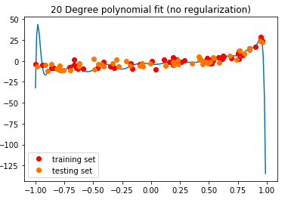

Although the fit appears to have very low error overall, it does not look like a high quality fit. It certainly looks to be overfitting the given data, as can be seen especially by the large peak between the first two data points and the vertical asymptotes at the start and end of the given data set. It is also worth noting that the validation MSE is ~200 times greater than the training MSE, which further supports that this is not a good fit.

2.

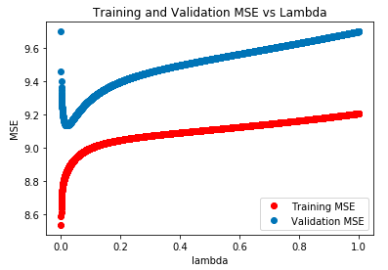

The best value of lambda is 0.196, where the validation MSE is at a minimum. For this given lambda, the MSE of the test set is 10.733.

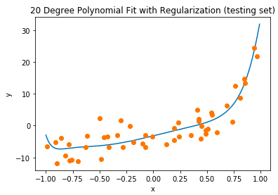

This fit has a lower MSE for the testing set than the first fit, and does not appear to be overfitting. It is smooth overall, and appears to be a good predictor for other data points. It is a high quality fit.

3.

I think that the degree of the polynomial is either 2 or 4. The visualization produced in the previous question shows that it is certainly not close to a 20-degree polynomial, and that it really only has one or two local minima. The reason for the ambiguity is due to the feature of the curve around x = -1.0. Here, the curve appears to have an inflection point, which could support it being a 4-degree polynomial. However, this could be due to a lack of data points in this area, or just variance. In those cases, a 2-degree may fit the profile fine.

# 2 Gradient Descent for Regression

1.

With the given learning rate of 1E-6, the system takes a long time to converge. The graph given is for 10000 epochs, which will be used throughout, as per the professor’s suggestion.

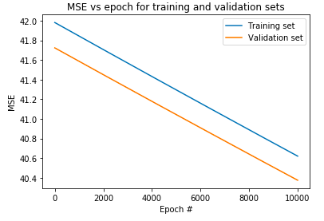

2.

Shown below are some of the values of alpha and the corresponding MSEs.

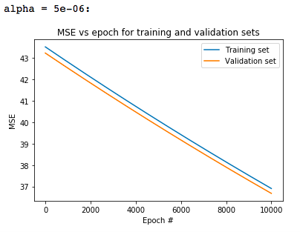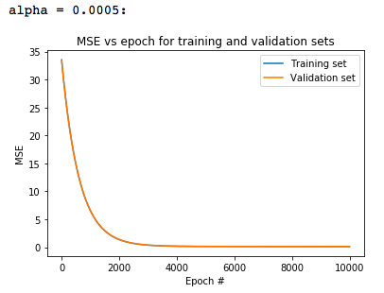

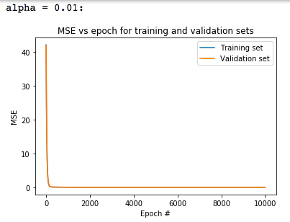 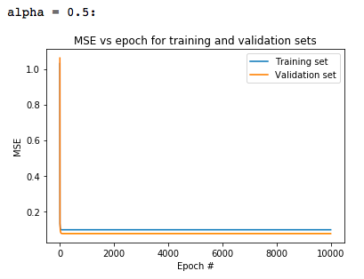

One can see that the system converges more quickly as alpha is increased, but after a point the training and validation MSE may separate (see alpha = 0.5).

After selecting the best alpha (i.e. the alpha that yields the lowest validation set MSE), **the MSE of the test data was 0.06923.**

3.

Below are visualizations of the fit for 5 different epochs. Note that the “best” alpha varied from run to run between 0.01 and 1. In the cases where alpha was greater, convergence was faster and the graphs below would be for lower Epoch values.

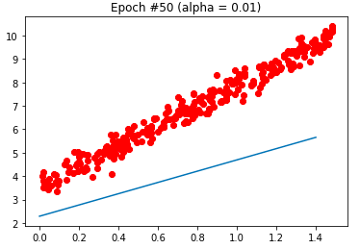

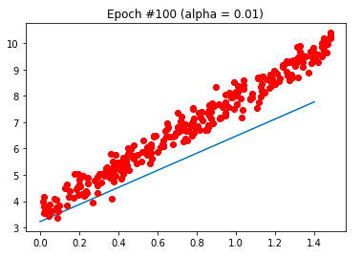

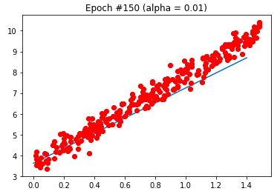

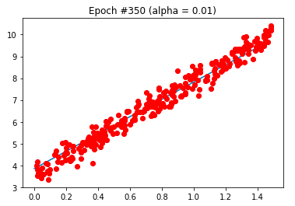

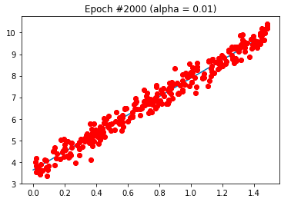

# 3 Real Life Dataset

1.

Using the sample mean to fill in the missing attributes in each column is a good choice, although perhaps not the best. Using the mean helps to ensure that the missing attribute, when corrected, does not have a significant impact on the output of that example. If, on the other hand, we used the sample mean summed with random variance, higher variance values may lead to poorer output values.

One potential alternative is to use some sort of interpolated or extrapolated value, based on another related value. This only works if we have another value that we feel is somewhat related. For instance, if each row represents a person, and we have their distance to the nearest supermarket, but are missing their distance to the nearest school, we may be able to use the complete data to interpolate how far they are roughly from the school. In this case, I do not know of any such relations, and thus will stick to the mean.

2.

The data was partitioned randomly, as detailed. Then, the parameters were learnt for each partition, and the testing MSE was calculated. Below is, for each model, the MSE and the parameters. The minimum MSE was 9.5455E-07, which was found for the first partition.

For each input column, x, we have two bs (or ws). We get y = SUM(xi*b1 + b0), which is why there are so many parameters. I feel that I made a mistake in interpreting the question, which is why I have so many parameters.

Paritition 1: Training MSE = 7.71743866187e-06, Testing MSE = 9.54550166631e-07

bs = [[ 3.44854640e-01 -3.64405882e-03]

[ 2.39029069e-01 2.93299580e-05]

[ 2.74725697e-01 -7.27234276e-07]

[ 0.00000000e+00 0.00000000e+00]

[ 2.59799115e-01 -3.45223896e-03]

[ 2.03988641e-01 6.75772169e-01]

[ 2.44544033e-01 -8.08863092e-03]

[ 1.31070312e-01 6.04513237e-01]

[ 7.40054044e-01 -6.62980676e-01]

[ 2.32210982e-01 5.62622303e-02]

[ 1.95526219e-01 3.16767589e-01]

[ 1.95116501e-01 1.08862940e-01]

[ 1.09672071e-01 2.69466082e-01]

[ 1.88817332e-01 1.58508411e-01]

[ 2.01894965e-01 9.10948993e-02]

[ 2.01054920e-01 6.48970548e-01]

[ 2.25608200e-01 2.17894450e-02]

[ 4.14210909e-01 -4.81621622e-01]

[ 4.80198512e-01 -4.31236307e-01]

[ 3.00011355e-01 -2.02353432e-01]

[ 6.18061229e-01 -7.61626343e-01]

[ 1.50116991e-01 1.91045403e-01]

[ 3.45672045e-02 6.47098194e-01]

[ 2.96708721e-01 -1.16461888e-01]

[ 4.38227762e-01 -5.27275784e-01]

[ 3.95199323e-01 -4.40884696e-01]

[ 3.43090880e-01 -2.78127211e-01]

[ 3.38371039e-01 -3.39512137e-01]

[ 2.66986644e-01 -1.31030501e-01]

[ 2.98476634e-01 -1.83152904e-01]

[ 2.92214269e-01 -1.84342698e-01]

[ 3.63381727e-01 -3.20807796e-01]

[ 1.96027254e-01 8.47207421e-01]

[ 7.06001510e-02 5.63321422e-01]

[ 8.84295541e-02 4.77148867e-01]

[ 1.21651379e-02 5.89665964e-01]

[ 3.74131264e-01 -3.72144010e-01]

[ 1.45341798e-02 6.24177202e-01]

[ 4.94525571e-01 -5.06544519e-01]

[ 2.40252696e-01 1.38155914e-03]

[ 2.99312474e-01 -1.33632283e-01]

[ 9.39197861e-02 3.66835668e-01]

[ 4.31105396e-01 -4.34515048e-01]

[ -6.67576696e-02 6.67562708e-01]

[ 4.88309562e-02 4.50388482e-01]

[ -1.15390577e-01 7.29189464e-01]

[ -1.01906112e-01 6.92984774e-01]

[ 1.17067696e-01 2.53795840e-01]

[ 7.42995471e-01 -8.24339560e-01]

[ 7.60964392e-01 -8.40208022e-01]

[ 7.19795975e-01 -7.25983846e-01]

[ 7.08352037e-01 -8.03103224e-01]

[ 2.73454770e-01 -6.46921464e-02]

[ 3.68560938e-01 -2.42135611e-01]

[ 2.00489452e-01 1.15453821e+00]

[ 5.08113759e-02 7.51030569e-01]

[ 2.16384770e-01 8.79600275e-01]

[ 1.71466706e-01 2.12390030e-01]

[ 1.36735479e-01 2.85269554e-01]

[ 1.06127238e-01 3.35039076e-01]

[ 7.14114267e-02 3.93228027e-01]

[ 1.95991845e-01 2.49347820e-01]

[ 1.92013917e-01 2.70702518e-01]

[ 1.90227027e-01 2.77783910e-01]

[ 1.88660569e-01 2.88381031e-01]

[ 4.58037915e-01 -2.75236513e-01]

[ 1.88669911e-01 3.47285867e-01]

[ 1.08762663e-01 4.93737668e-01]

[ 1.38064177e-01 4.06921509e-01]

[ 2.49613593e-01 -1.89539315e-02]

[ 3.19263742e-01 -1.58573598e-01]

[ 1.03176704e-01 3.38822338e-01]

[ 5.95599313e-01 -6.25600751e-01]

[ 1.42940127e-01 5.26085117e-01]

[ -7.38425164e-02 6.40086233e-01]

[ 3.47887010e-01 -3.30648171e-01]

[ 1.92671859e-01 6.73405116e-01]

[ 5.87740680e-01 -4.74023322e-01]

[ 5.69021253e-01 -5.92537266e-01]

[ 1.33846092e-01 5.18005536e-01]

[ 2.21978144e-01 4.32393479e-02]

[ 3.07618414e-01 -1.36550052e-01]

[ 1.09791271e-01 4.93991073e-01]

[ 1.33320041e-01 4.38569946e-01]

[ 2.97342769e-01 -2.16039002e-01]

[ 2.90126523e-01 -1.89517852e-01]

[ 2.85859146e-01 -1.69895331e-01]

[ 3.35531737e-01 -2.75314127e-01]

[ 3.42701409e-01 -2.75088865e-01]

[ 3.34278478e-01 -2.23915783e-01]

[ 3.43408664e-01 -2.68684332e-01]

[ 1.03726022e-03 4.88224232e-01]

[ 1.95307986e-01 1.02763284e-01]

[ 2.05385637e-01 8.80463504e-02]

[ 2.16940419e-01 8.21044232e-01]

[ 2.25136491e-01 8.73464761e-01]

[ 1.94830620e-01 2.15695685e-01]

[ 2.82903874e-01 -6.83447991e-02]

[ 3.49631257e-01 -2.00800433e-01]

[ 1.66534214e-01 1.16455103e-01]

[ 2.27755066e-01 1.97548217e-02]

[ 1.97932361e-01 6.29620848e-01]

[ 1.78042305e-01 2.89468098e-01]

[ 8.09994445e-01 -6.14475494e-01]

[ 1.76058521e-01 2.63757139e-01]

[ 1.85024283e-01 5.78676441e-01]

[ 1.29330732e-01 5.18961958e-01]

[ 1.30625123e-01 3.19196762e-01]

[ 1.77507820e-01 2.91871700e-01]

[ 7.12100790e-01 -6.83759579e-01]

[ 6.78716843e-01 -6.02257298e-01]

[ 9.45750374e-02 6.61811110e-01]

[ 2.19769939e-01 1.56763955e-01]

[ 2.23116068e-01 1.52483340e-01]

[ 8.37085328e-02 6.05837632e-01]

[ 1.74389561e-01 8.96068355e-01]

[ 7.20781582e-02 3.01874922e-01]

[ 2.02545883e-01 1.25236847e-01]

[ 2.24856464e-01 2.52194000e-01]

[ 1.59734084e-01 3.47001896e-01]

[ 2.22429968e-01 1.13303972e-01]

[ 1.81498934e-01 3.66618535e-01]

[ 1.97654895e-01 5.75894501e-01]

[ 4.11061052e-01 -2.43951165e-01]

[ 2.10208372e-01 6.92042698e-02]

[ 2.10728236e-01 3.49261013e-01]

[ 2.14896047e-01 1.33520661e-01]]

Paritition 2: Training MSE = 3.27778612688e-05, Testing MSE = 8.01869911515e-05

bs = [[ 2.98749658e-01 -2.04859206e-03]

[ 2.32732149e-01 9.50342016e-05]

[ 2.56215106e-01 -3.79967993e-07]

[ 0.00000000e+00 0.00000000e+00]

[ 2.31119694e-01 1.34362876e-03]

[ 2.00286305e-01 7.10069168e-01]

[ 3.03325369e-01 -1.39233737e-01]

[ 1.32006232e-01 5.79926489e-01]

[ 7.24315054e-01 -6.43117725e-01]

[ 2.39335840e-01 -5.31231021e-03]

[ 2.02836026e-01 2.55570936e-01]

[ 2.09941079e-01 6.60987188e-02]

[ 1.24866900e-01 2.25143783e-01]

[ 1.94072543e-01 1.27869441e-01]

[ 1.89807038e-01 1.16599082e-01]

[ 1.97542125e-01 6.82604223e-01]

[ 2.17916326e-01 3.02127162e-02]

[ 4.19122819e-01 -5.11282722e-01]

[ 4.52140577e-01 -3.79854854e-01]

[ 2.79548525e-01 -1.37161338e-01]

[ 6.06332107e-01 -7.48850735e-01]

[ 1.61853037e-01 1.64211467e-01]

[ 5.64790178e-02 5.80118995e-01]

[ 3.11217028e-01 -1.53036216e-01]

[ 4.43085119e-01 -5.55624982e-01]

[ 3.91034777e-01 -4.47713704e-01]

[ 3.31973306e-01 -2.60798095e-01]

[ 3.54700517e-01 -4.10983660e-01]

[ 2.61498587e-01 -1.12660777e-01]

[ 3.04505266e-01 -2.07908579e-01]

[ 2.77310945e-01 -1.36293607e-01]

[ 3.55485886e-01 -3.05080290e-01]

[ 1.91971633e-01 8.84664111e-01]

[ 7.81357584e-02 5.21713394e-01]

[ 1.08509915e-01 4.09150725e-01]

[ 3.95421759e-02 5.18839154e-01]

[ 3.57280286e-01 -3.30083410e-01]

[ 3.63989855e-02 5.63904399e-01]

[ 4.35043264e-01 -3.90503253e-01]

[ 2.74946923e-01 -9.23498373e-02]

[ 2.70042330e-01 -7.10945138e-02]

[ 1.13802442e-01 3.17440100e-01]

[ 4.18207802e-01 -4.10270226e-01]

[ -7.58815541e-02 6.83555608e-01]

[ 8.51109273e-02 3.48918677e-01]

[ -1.16720621e-01 7.28051021e-01]

[ -1.07062293e-01 6.99948394e-01]

[ 1.79265071e-01 1.22500760e-01]

[ 7.38041522e-01 -8.20439754e-01]

[ 7.52328059e-01 -8.31439352e-01]

[ 7.12179425e-01 -7.12167748e-01]

[ 6.95536681e-01 -7.87456253e-01]

[ 2.34212239e-01 8.42873639e-03]

[ 3.21644387e-01 -1.54711393e-01]

[ 1.98134063e-01 1.25474341e+00]

[ 5.56784684e-02 7.21462459e-01]

[ 2.17333335e-01 7.55039753e-01]

[ 1.86594017e-01 1.59265286e-01]

[ 1.61734438e-01 2.09399851e-01]

[ 1.33160884e-01 2.58625375e-01]

[ 1.04183499e-01 3.07784570e-01]

[ 2.06186182e-01 1.81435792e-01]

[ 2.03793387e-01 1.93053593e-01]

[ 2.01824024e-01 2.01259989e-01]

[ 1.99817879e-01 2.14794087e-01]

[ 4.02666443e-01 -2.07529037e-01]

[ 1.98786325e-01 2.73120340e-01]

[ 1.34404083e-01 3.99580195e-01]

[ 1.66177643e-01 2.95269259e-01]

[ 3.03521137e-01 -1.41751876e-01]

[ 3.74245096e-01 -2.76977027e-01]

[ 1.42990159e-01 2.36149203e-01]

[ 5.74421330e-01 -6.03984331e-01]

[ 1.54068940e-01 4.61976412e-01]

[ -8.08064424e-02 6.45502820e-01]

[ 3.41895267e-01 -3.22588945e-01]

[ 1.87619127e-01 6.82239984e-01]

[ 5.15029121e-01 -3.85343931e-01]

[ 5.53719584e-01 -5.79999235e-01]

[ 1.38510140e-01 4.86422554e-01]

[ 2.25760066e-01 2.93023744e-02]

[ 2.83018903e-01 -8.85151420e-02]

[ 1.11441704e-01 4.67584199e-01]

[ 1.44189606e-01 3.83785328e-01]

[ 3.02200220e-01 -2.50263382e-01]

[ 2.94374631e-01 -2.21357105e-01]

[ 2.88692241e-01 -1.94745988e-01]

[ 3.35240212e-01 -2.85332899e-01]

[ 3.45620249e-01 -2.93136569e-01]

[ 3.38237480e-01 -2.39922717e-01]

[ 3.46912175e-01 -2.87509431e-01]

[ 3.13703121e-02 4.24424717e-01]

[ 2.11525336e-01 6.06215745e-02]

[ 1.95764168e-01 1.05928794e-01]

[ 2.15368595e-01 9.01416507e-01]

[ 2.24734132e-01 6.88408124e-01]

[ 2.05130221e-01 1.60177007e-01]

[ 2.81980683e-01 -7.13130373e-02]

[ 3.41914634e-01 -1.96777354e-01]

[ 1.96936154e-01 6.80867042e-02]

[ 2.62448898e-01 -3.74338398e-02]

[ 2.18835471e-01 2.94659479e-01]

[ 1.95967838e-01 1.96811369e-01]

[ 5.51059966e-01 -3.37072156e-01]

[ 1.70300783e-01 2.77619293e-01]

[ 2.05477345e-01 3.46342170e-01]

[ 1.31645633e-01 4.93515065e-01]

[ 1.12245107e-01 3.64070938e-01]

[ 1.95682671e-01 1.98094074e-01]

[ 5.86395861e-01 -5.04435071e-01]

[ 5.62475583e-01 -4.46427740e-01]

[ 1.20854837e-01 5.39281544e-01]

[ 2.16836905e-01 1.56510455e-01]

[ 2.38943787e-01 -3.51342565e-03]

[ 1.13053108e-01 4.81647360e-01]

[ 1.84785240e-01 7.24643113e-01]

[ 2.24145569e-01 2.59591181e-02]

[ 2.24169576e-01 4.65021490e-02]

[ 2.16788397e-01 3.26734840e-01]

[ 1.72297675e-01 2.88781656e-01]

[ 2.15615813e-01 1.45187684e-01]

[ 1.85590112e-01 3.29391321e-01]

[ 2.22602042e-01 2.15806830e-01]

[ 1.48670762e-01 1.27846109e-01]

[ 2.00543733e-01 8.55913280e-02]

[ 2.03315248e-01 3.44293724e-01]

[ 2.24196890e-01 7.39701854e-02]]

Paritition 3: Training MSE = 2.32679239146e-05, Testing MSE = 0.000454759192628

bs = [[ 3.14502524e-01 -2.84478758e-03]

[ 2.20175024e-01 2.17012941e-04]

[ 2.59664070e-01 -5.79516001e-07]

[ 0.00000000e+00 0.00000000e+00]

[ 2.65130541e-01 -5.86056028e-03]

[ 1.98174593e-01 6.25074167e-01]

[ 2.43874389e-01 -2.40960763e-02]

[ 1.33170313e-01 5.42735686e-01]

[ 7.06752343e-01 -6.30818502e-01]

[ 2.30115582e-01 1.72411991e-02]

[ 1.91333623e-01 2.96681093e-01]

[ 1.80367351e-01 1.23154291e-01]

[ 9.54241246e-02 2.80345482e-01]

[ 1.79785053e-01 1.58114247e-01]

[ 1.92507373e-01 9.38637948e-02]

[ 1.95479630e-01 5.98123204e-01]

[ 2.36048219e-01 -4.79998404e-03]

[ 4.10407319e-01 -4.83311186e-01]

[ 4.53789899e-01 -3.96262219e-01]

[ 2.66204129e-01 -1.16794138e-01]

[ 6.01203740e-01 -7.34426882e-01]

[ 1.48101785e-01 1.77969715e-01]

[ 4.40764567e-02 5.94250591e-01]

[ 3.12207245e-01 -1.65876574e-01]

[ 4.34029830e-01 -5.27174756e-01]

[ 3.97327118e-01 -4.63191706e-01]

[ 3.47008137e-01 -3.05581952e-01]

[ 3.45538891e-01 -3.85057697e-01]

[ 2.64725474e-01 -1.54527458e-01]

[ 2.88199905e-01 -1.72156302e-01]

[ 2.82705313e-01 -1.76652282e-01]

[ 3.60933713e-01 -3.28943448e-01]

[ 1.89732435e-01 8.22776378e-01]

[ 7.08770658e-02 5.38250370e-01]

[ 8.19676573e-02 4.74550957e-01]

[ 1.53771742e-02 5.66979282e-01]

[ 3.71967844e-01 -3.77890846e-01]

[ 2.49829198e-02 5.73425856e-01]

[ 4.68358163e-01 -4.70057350e-01]

[ 2.43070005e-01 -2.62552439e-02]

[ 2.68157655e-01 -7.96555382e-02]

[ 8.13371900e-02 3.88270319e-01]

[ 4.38513696e-01 -4.59378763e-01]

[ -5.73564164e-02 6.40247881e-01]

[ 6.09356029e-02 3.97679236e-01]

[ -1.08172999e-01 7.07479382e-01]

[ -9.37805291e-02 6.69947814e-01]

[ 1.28905160e-01 2.12177047e-01]

[ 7.20053766e-01 -7.92836426e-01]

[ 7.37800467e-01 -8.10218458e-01]

[ 7.06241725e-01 -7.08264701e-01]

[ 6.96480056e-01 -7.92806902e-01]

[ 2.13476437e-01 3.79937408e-02]

[ 3.11482180e-01 -1.48298849e-01]

[ 1.95618103e-01 1.13991750e+00]

[ 4.92445221e-02 7.37210149e-01]

[ 2.10489350e-01 7.59335783e-01]

[ 1.74694724e-01 1.82261141e-01]

[ 1.54019054e-01 2.17740136e-01]

[ 1.26109729e-01 2.64519967e-01]

[ 9.07794544e-02 3.30553029e-01]

[ 1.92834051e-01 2.24119186e-01]

[ 1.89891908e-01 2.39078663e-01]

[ 1.89029531e-01 2.39963775e-01]

[ 1.87358241e-01 2.52335660e-01]

[ 4.15183317e-01 -2.31122553e-01]

[ 1.87885633e-01 3.01195693e-01]

[ 1.14363653e-01 4.42469095e-01]

[ 1.42547084e-01 3.56196310e-01]

[ 2.51208325e-01 -3.98670691e-02]

[ 3.19259250e-01 -1.74427726e-01]

[ 9.54954323e-02 3.40644034e-01]

[ 5.90900415e-01 -6.27564344e-01]

[ 1.45275249e-01 4.73436310e-01]

[ -6.85203737e-02 6.15199401e-01]

[ 3.29018745e-01 -3.04385936e-01]

[ 1.87720927e-01 6.26355957e-01]

[ 5.00999691e-01 -3.69943395e-01]

[ 5.67150126e-01 -6.00678267e-01]

[ 1.30836009e-01 5.08268071e-01]

[ 2.24908395e-01 1.80201652e-02]

[ 2.79341818e-01 -9.34108412e-02]

[ 1.05293545e-01 4.80182488e-01]

[ 1.34220189e-01 4.02772913e-01]

[ 3.00562095e-01 -2.54335420e-01]

[ 2.92591792e-01 -2.26000209e-01]

[ 2.87599863e-01 -2.03259935e-01]

[ 3.34512071e-01 -2.93570790e-01]

[ 3.44006591e-01 -2.96964678e-01]

[ 3.38495684e-01 -2.48072374e-01]

[ 3.44404376e-01 -2.88480490e-01]

[ 1.81739076e-02 4.36625037e-01]

[ 1.92871585e-01 8.84573223e-02]

[ 2.05297443e-01 6.77180457e-02]

[ 2.08895738e-01 8.59376075e-01]

[ 2.16032707e-01 8.65942255e-01]

[ 1.95148088e-01 1.74685436e-01]

[ 2.65935963e-01 -5.49536452e-02]

[ 3.59460578e-01 -2.34056888e-01]

[ 1.83605100e-01 7.78229679e-02]

[ 2.45302403e-01 -1.94413682e-02]

[ 1.79803381e-01 7.66904586e-01]

[ 1.94154674e-01 1.78087491e-01]

[ 9.46537867e-01 -7.71204112e-01]

[ 1.98098589e-01 1.41375410e-01]

[ 1.72530747e-01 6.17600956e-01]

[ 1.27361372e-01 4.92506765e-01]

[ 1.42944077e-01 2.60853219e-01]

[ 1.94206196e-01 1.77827121e-01]

[ 5.84125458e-01 -5.08619079e-01]

[ 7.20778251e-01 -6.71150587e-01]

[ 1.04966799e-01 5.81287456e-01]

[ 1.93167602e-01 2.92467331e-01]

[ 2.07908727e-01 2.15984121e-01]

[ 5.28686747e-02 6.94563019e-01]

[ 1.62046726e-01 9.34360553e-01]

[ 1.57935112e-01 1.34626994e-01]

[ 2.36723069e-01 -1.33176113e-02]

[ 2.12190791e-01 3.07007507e-01]

[ 1.58997156e-01 3.25517600e-01]

[ 2.14442895e-01 1.15112135e-01]

[ 1.53582296e-01 4.90818119e-01]

[ 1.77525724e-01 7.20487958e-01]

[ 3.45831519e-01 -1.62412311e-01]

[ 2.11858408e-01 4.75014148e-02]

[ 2.06379888e-01 2.91011937e-01]

[ 1.95164197e-01 1.92082516e-01]]

Paritition 4: Training MSE = 1.5084704981e-06, Testing MSE = 1.45127843161e-05

bs = [[ 3.23280999e-01 -2.74367873e-03]

[ 2.33647317e-01 1.76837093e-04]

[ 2.62403311e-01 -3.87541756e-07]

[ 0.00000000e+00 0.00000000e+00]

[ 2.50964387e-01 -1.22157649e-03]

[ 2.05195756e-01 6.67303979e-01]

[ 2.70290864e-01 -5.60074430e-02]

[ 1.39348849e-01 5.72254638e-01]

[ 7.30637430e-01 -6.49363649e-01]

[ 2.37030100e-01 4.71694643e-02]

[ 1.95585978e-01 3.22241740e-01]

[ 2.04359695e-01 9.43078011e-02]

[ 1.28878870e-01 2.32829013e-01]

[ 2.00348360e-01 1.30336002e-01]

[ 1.97923493e-01 1.09612999e-01]

[ 2.00906344e-01 6.61062126e-01]

[ 1.98987336e-01 6.38308112e-02]

[ 4.28339984e-01 -5.11151812e-01]

[ 4.79464768e-01 -4.20600710e-01]

[ 2.92423046e-01 -1.66392050e-01]

[ 6.26357656e-01 -7.65767703e-01]

[ 1.54216970e-01 1.91131971e-01]

[ 5.35486530e-02 6.03488447e-01]

[ 3.20164163e-01 -1.57214769e-01]

[ 4.50701334e-01 -5.49399682e-01]

[ 4.02552451e-01 -4.51532504e-01]

[ 3.50353341e-01 -2.87210875e-01]

[ 3.54737815e-01 -3.87307352e-01]

[ 2.78191174e-01 -1.73085888e-01]

[ 2.96259822e-01 -1.59836757e-01]

[ 2.89590198e-01 -1.63270921e-01]

[ 3.45505240e-01 -2.59631444e-01]

[ 1.98817139e-01 7.90293199e-01]

[ 7.08365021e-02 5.76200236e-01]

[ 9.17993949e-02 4.84089301e-01]

[ 2.31136185e-02 5.78538255e-01]

[ 3.78066416e-01 -3.66384536e-01]

[ 2.65035037e-02 5.96592924e-01]

[ 4.78373376e-01 -4.68232351e-01]

[ 2.70514842e-01 -6.74749046e-02]

[ 2.97972178e-01 -1.20746375e-01]

[ 1.03347967e-01 3.66244467e-01]

[ 4.45777794e-01 -4.52568458e-01]

[ -7.25170364e-02 6.86075282e-01]

[ 7.26683727e-02 3.91262738e-01]

[ -1.17888787e-01 7.41564417e-01]

[ -1.07054506e-01 7.09762012e-01]

[ 1.19337145e-01 2.55643873e-01]

[ 7.57650008e-01 -8.38828781e-01]

[ 7.81044144e-01 -8.62446399e-01]

[ 7.38474700e-01 -7.41952836e-01]

[ 7.21914320e-01 -8.18957340e-01]

[ 2.77103876e-01 -6.58061743e-02]

[ 3.84615692e-01 -2.66921773e-01]

[ 2.05460550e-01 1.05604685e+00]

[ 5.83433375e-02 7.27747200e-01]

[ 2.16906692e-01 8.91948109e-01]

[ 1.84753351e-01 1.84406472e-01]

[ 1.55872359e-01 2.42677805e-01]

[ 1.26721527e-01 2.92395444e-01]

[ 8.22929890e-02 3.74630367e-01]

[ 1.97419982e-01 2.51271347e-01]

[ 1.93471384e-01 2.71742745e-01]

[ 1.91778649e-01 2.77389900e-01]

[ 1.89357680e-01 2.92662899e-01]

[ 4.78193481e-01 -2.99058908e-01]

[ 1.89294553e-01 3.58350465e-01]

[ 1.07119532e-01 5.10492475e-01]

[ 1.39017513e-01 4.17463841e-01]

[ 2.62491629e-01 -3.95788119e-02]

[ 3.31358563e-01 -1.76030125e-01]

[ 1.10099992e-01 3.33708543e-01]

[ 5.93450903e-01 -6.25178665e-01]

[ 1.43802625e-01 5.29577452e-01]

[ -9.99757352e-02 6.94394437e-01]

[ 3.56456712e-01 -3.50692371e-01]

[ 1.95419105e-01 6.09352701e-01]

[ 5.46987858e-01 -4.21979181e-01]

[ 5.71507312e-01 -6.01525797e-01]

[ 1.23846462e-01 6.06549014e-01]

[ 2.09110725e-01 8.12839631e-02]

[ 2.92617314e-01 -9.81834802e-02]

[ 1.11908953e-01 5.02716299e-01]

[ 1.35763711e-01 4.46599403e-01]

[ 3.08328181e-01 -2.44631842e-01]

[ 3.00721989e-01 -2.16698897e-01]

[ 2.95829857e-01 -1.93632394e-01]

[ 3.42903514e-01 -2.84979189e-01]

[ 3.52690575e-01 -2.92043998e-01]

[ 3.45760795e-01 -2.40931287e-01]

[ 3.56101187e-01 -2.91803841e-01]

[ 2.02955820e-02 4.57331609e-01]

[ 2.13552955e-01 6.84216936e-02]

[ 2.16033586e-01 7.03519128e-02]

[ 2.18935227e-01 8.76485074e-01]

[ 2.25278633e-01 7.27199144e-01]

[ 1.92497347e-01 2.36202771e-01]

[ 3.03466204e-01 -9.86509482e-02]

[ 3.37326074e-01 -1.75305234e-01]

[ 1.71949925e-01 1.16357117e-01]

[ 2.41059108e-01 4.92445354e-03]

[ 1.96048882e-01 7.04767005e-01]

[ 2.18175796e-01 1.18931898e-01]

[ 9.09631851e-01 -7.18542534e-01]

[ 2.21580845e-01 9.16290732e-02]

[ 1.89133184e-01 5.64374173e-01]

[ 1.65104212e-01 3.68265657e-01]

[ 1.78541529e-01 1.92451149e-01]

[ 2.18216770e-01 1.18730626e-01]

[ 5.68725195e-01 -4.70362246e-01]

[ 5.94439484e-01 -4.81426702e-01]

[ 1.17499654e-01 5.79766384e-01]

[ 2.05348847e-01 2.83061670e-01]

[ 2.33443477e-01 9.46514668e-02]

[ 1.05511544e-01 5.34898372e-01]

[ 1.82227365e-01 8.38240158e-01]

[ 1.90571034e-01 9.66617280e-02]

[ 2.36589990e-01 2.49012493e-02]

[ 2.22778873e-01 3.19660560e-01]

[ 1.72072012e-01 3.10961656e-01]

[ 2.15706636e-01 1.75423111e-01]

[ 1.82348683e-01 3.80672985e-01]

[ 1.91295270e-01 6.99682007e-01]

[ 3.25481089e-01 -1.16562417e-01]

[ 1.93837043e-01 1.13385917e-01]

[ 2.12341806e-01 3.17221964e-01]

[ 2.31989448e-01 6.19982744e-02]]

Paritition 5: Training MSE = 4.03872660792e-06, Testing MSE = 0.00131691390223

bs = [[ 3.26962984e-01 -2.99076663e-03]

[ 2.34436738e-01 9.58692270e-05]

[ 2.84416922e-01 -9.61829284e-07]

[ 0.00000000e+00 0.00000000e+00]

[ 2.69882035e-01 -5.35815470e-03]

[ 1.99201220e-01 6.00812229e-01]

[ 2.74869870e-01 -7.56120186e-02]

[ 1.34960996e-01 5.96240392e-01]

[ 7.42619534e-01 -6.68159898e-01]

[ 2.20995524e-01 1.22099050e-01]

[ 1.95649177e-01 2.99022525e-01]

[ 2.14614624e-01 6.00833846e-02]

[ 9.58641829e-02 2.94600905e-01]

[ 1.88681757e-01 1.54853013e-01]

[ 2.00128342e-01 9.44104381e-02]

[ 1.96294458e-01 5.90123828e-01]

[ 2.12495067e-01 3.97135798e-02]

[ 4.05093086e-01 -4.54106102e-01]

[ 4.60783683e-01 -3.94843644e-01]

[ 2.90639448e-01 -1.72298784e-01]

[ 6.06093553e-01 -7.37084302e-01]

[ 1.70509695e-01 1.48127370e-01]

[ 4.53277301e-02 6.14220700e-01]

[ 3.15835413e-01 -1.59600639e-01]

[ 4.29935087e-01 -5.01475959e-01]

[ 3.82060789e-01 -3.99553678e-01]

[ 3.27533437e-01 -2.34205164e-01]

[ 3.52703164e-01 -3.83011949e-01]

[ 2.63733639e-01 -1.16035720e-01]

[ 2.87004443e-01 -1.43608786e-01]

[ 2.70915857e-01 -1.11000335e-01]

[ 3.38142222e-01 -2.51744524e-01]

[ 1.94670179e-01 7.05136082e-01]

[ 7.88957176e-02 5.29286101e-01]

[ 9.68600713e-02 4.51213519e-01]

[ 2.92141014e-02 5.50791155e-01]

[ 3.66878413e-01 -3.46002409e-01]

[ 3.99423133e-02 5.52347675e-01]

[ 4.50600985e-01 -4.18226681e-01]

[ 2.61342749e-01 -5.24870406e-02]

[ 2.89846498e-01 -1.12399605e-01]

[ 1.18143290e-01 3.11303444e-01]

[ 4.25356036e-01 -4.14893924e-01]

[ -6.41197959e-02 6.51611227e-01]

[ 3.85629234e-02 4.63337184e-01]

[ -1.18143999e-01 7.27057126e-01]

[ -1.03040811e-01 6.86337586e-01]

[ 1.38464280e-01 2.08388395e-01]

[ 7.35515159e-01 -8.15796640e-01]

[ 7.59832380e-01 -8.40290524e-01]

[ 7.11096491e-01 -7.12129076e-01]

[ 7.09949969e-01 -8.12019459e-01]

[ 2.57491891e-01 -3.45906166e-02]

[ 3.36253349e-01 -1.81005958e-01]

[ 2.02746789e-01 8.75590623e-01]

[ 4.47854243e-02 7.76917172e-01]

[ 2.12008638e-01 7.65124454e-01]

[ 1.66632033e-01 2.30068593e-01]

[ 1.34881093e-01 2.94207329e-01]

[ 9.93952766e-02 3.54047560e-01]

[ 6.27854994e-02 4.16139905e-01]

[ 1.90746429e-01 2.68325755e-01]

[ 1.87805880e-01 2.83723124e-01]

[ 1.85702431e-01 2.89431995e-01]

[ 1.84265209e-01 2.99972992e-01]

[ 4.56330474e-01 -2.76246041e-01]

[ 1.85905669e-01 3.48104896e-01]

[ 1.21009535e-01 4.41767987e-01]

[ 1.52845037e-01 3.44476782e-01]

[ 2.71612544e-01 -6.85243998e-02]

[ 3.46061707e-01 -2.15057636e-01]

[ 1.09328567e-01 3.25955183e-01]

[ 6.18661843e-01 -6.72253671e-01]

[ 1.43353201e-01 5.14965750e-01]

[ -8.23292140e-02 6.52431951e-01]

[ 3.37991512e-01 -3.11228012e-01]

[ 1.88483570e-01 6.03646350e-01]

[ 5.28699954e-01 -3.98563376e-01]

[ 5.94128257e-01 -6.44506465e-01]

[ 1.31954747e-01 5.13836596e-01]

[ 2.31314867e-01 2.00926987e-02]

[ 2.96081327e-01 -1.14230219e-01]

[ 1.20430640e-01 4.53584558e-01]

[ 1.39769225e-01 4.09379219e-01]

[ 2.90958633e-01 -1.91189050e-01]

[ 2.84150392e-01 -1.65576023e-01]

[ 2.79476001e-01 -1.44737169e-01]

[ 3.23878663e-01 -2.42442559e-01]

[ 3.28989821e-01 -2.38837055e-01]

[ 3.21602534e-01 -1.92737733e-01]

[ 3.30753730e-01 -2.36452209e-01]

[ 2.99110291e-02 4.28687160e-01]

[ 1.96454993e-01 9.72282171e-02]

[ 2.09172740e-01 7.62845627e-02]

[ 2.12687992e-01 7.29719857e-01]

[ 2.19553133e-01 7.54567031e-01]

[ 1.89104028e-01 2.33794969e-01]

[ 3.16497741e-01 -1.25452774e-01]

[ 3.70230110e-01 -2.42207996e-01]

[ 1.95311802e-01 7.04228819e-02]

[ 2.85614442e-01 -6.94655801e-02]

[ 1.82675517e-01 7.88101022e-01]

[ 1.82560173e-01 2.64159030e-01]

[ 9.50531572e-01 -7.70736345e-01]

[ 1.91442572e-01 1.97438714e-01]

[ 1.69007538e-01 6.95955468e-01]

[ 1.63000667e-01 3.56667670e-01]

[ 1.62451097e-01 2.25741565e-01]

[ 1.82309489e-01 2.65264058e-01]

[ 6.29678549e-01 -5.62815263e-01]

[ 6.57446412e-01 -5.73593469e-01]

[ 9.22077789e-02 6.81875931e-01]

[ 2.01291490e-01 2.79793045e-01]

[ 2.14391442e-01 2.17945166e-01]

[ 8.01541615e-02 6.17843927e-01]

[ 1.80318768e-01 7.71561499e-01]

[ 8.95486676e-02 2.69418426e-01]

[ 2.01328948e-01 1.24953772e-01]

[ 2.09605849e-01 4.34389387e-01]

[ 1.56578442e-01 3.52526112e-01]

[ 2.12535335e-01 1.70360560e-01]

[ 1.46136053e-01 5.57879677e-01]

[ 1.76802521e-01 7.83974407e-01]

[ 4.30818257e-01 -2.72727449e-01]

[ 2.24188607e-01 3.57321782e-02]

[ 2.07936380e-01 3.37184551e-01]

[ 1.90891464e-01 2.50410065e-01]]

The average MSE was 0.000373465484099.

3.

I was not able to complete this part in time for the submission.